**Project Writeup (Page 1):** <https://github.com/davidech426/VehicleFinalMaps> (Github repo)

1. Application Concept
   1. For this project, we are tasked to implement vehicle fine maps. It is a data-driven application that let’s users track their driving patterns and assess it against a compiled and analyzed data set. Specifically, the application will track the user’s speed and then display a likelihood of getting a ticket according to their current driving pattern. Overall, the main purpose of the application is to allow the user to reduce the probability of receiving a fine.
2. Key Functionality
   1. Each user has their own account which holds specific information about their particular driving patterns.
   2. Uses this user-specific data in addition to the data-driven analysis to display the likelihood of receiving a ticket.
   3. While driving, if the car is AndroidAuto compatible, we can send a notification to the user’s car dashboard notifying them of their current driving pattern. If they pass a certain threshold a notification will pop up displaying a need to slow down, but otherwise it will let the driver know their current likelihood of receiving a ticket.
3. Rough Architecture
   1. User Interface/ Authentication
   2. Single screen displaying driving pattern against data.
   3. AndroidAuto displaying driving pattern against data.
4. List of Android System components we expect to implement
   1. Widgets and notifications, Android Activity, Broadcast Receivers, Services
5. Special resources we may need, such as networked server, database, etc
   1. A database/firebase to store user authentication information and user data
   2. AndroidAuto
   3. Google Maps Speed API
6. Enumerate the work items each team member is responsible for
   1. David Echeverria
      1. User Authentication/Work with Database
   2. Nick Brown
      1. Extracting data, User Interface
   3. Koonj Patel
      1. User Interface, AndroidAuto display

**Storyboard (Page 2):**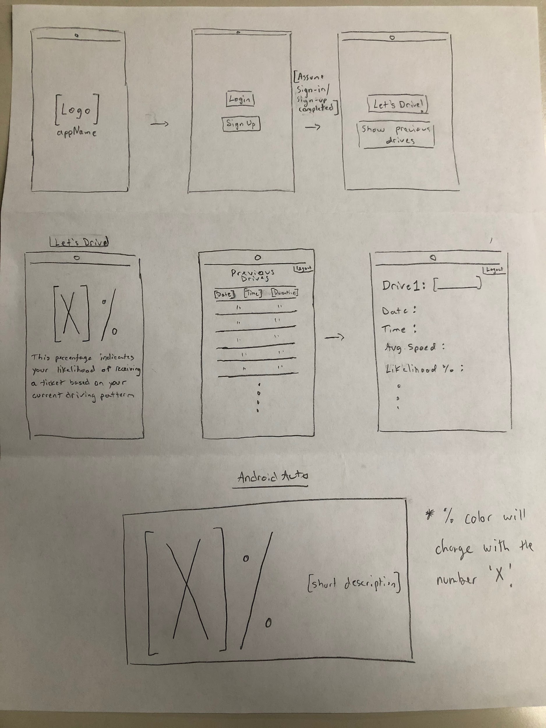

**Work Contributions:**

Koonj - All have equal work.

David - All have equal work.

Nick - All have equal work.